**TO EVALUATE THE EFFECTS OF TAI-CHI EXERCISES VERSUS KINESIOTAPING WITH CONVENTIONAL PHYSIOTHERAPY IN ACUTE OSTEOARTHRITIS OF THE KNEE JOINT- A COMPARATIVE STUDY**

**Charvi bhatnagar, Dr. Shailendra Mehta**

Abstract

**BACKGROUND:** Osteoarthritis is one of the most common degenerative joint diseases affecting people over 40 years of age. Osteoarthritis of knee usually develops slowly and the pain it causes worsens over time.Treatment designed for knee osteoarthritis includes relieve pain, improve function, changing life style, modifying daily activities and limit disabilities. Tai Chi is a traditional Chinese exercise program consisting of a sequence of whole body movement that are performed in a slow, relaxed manner with an emphasis on awareness of posture alignment and synchronized breathing. Conventional Physiotherapy treatment includes electrotherapy and strengthening and stretching exercises.Knee taping is believed to relieve pain by improving alignment of the patellofemoral joint and/or unloading inflamed soft tissues.

**METHODOLOGY:** The sample consisted of 50 patients diagnosed with acute osteoarthritis of knee, aged between 40 years to 50 years, randomly assigned as per inclusion and exclusion criteria to either in group A ie. experimental (n = 25) or group B ie. control (n = 25) group. Both groups attended 16 weekly, 40 minutes sessions at least 3 times each week. Participants in the group A received Tai Chi exercises and Group B received kinesio taping with conventional physiotherapy. At pre and post-test, measures were collected for pain, stiffness and functional limitations. Pain intensity was measured by Numerical Pain Rating Scale (NPRS) and stiffness and functional limitation was assessed by Western Ontario and McMaster Universities Osteoarthritis Index (WOMAC).

**RESULT:** The mean age of subjects in group A was 45.32±0.62 and in the group B was 46.04±0.64. The pre-test and post-test values of pain intensity of Numerical Pain Rating Scale (NPRS) were 7.52 and 2.32 for group A and 7.56 and 2.64 for group B and mean improvement was 5.20 in Group A and 4.92 in Group B. The pre-test and post-test values of Western Ontario and McMaster Universities Osteoarthritis Index (WOMAC) were 67.44 and 18.76 for group A and 68.80 and 25.08 for group B and mean improvement was 48.68 in Group A and 43.72 in Group B. The post-test mean difference for pain scores between both groups was 0.32, which was not significant and for stiffness and physical function were 6.32, which was significant. The study resulted that group A treated with tai-chi exercises and group B treated with kinesio taping with conventional physiotherapy had almost equal effect on pain and tai-chi exercises had superior effects on reducing knee stiffness and improving physical functions in acute osteoarthritis of knee.

**CONCLUSION:** The study concluded that both Tai Chi and kinesio taping with conventional physiotherapy to be an effective in alleviating the symptoms of acute osteoarthritis of knee. Both Tai Chi exercises and kinesio taping with conventional physiotherapy can be effectively used to treat acute osteoarthritis of knee.

**KEY WORDS:** Osteoarthritis, Knee, Tai Chi, Kinesio taping, Conventional Physiotherapy

**INTRODUCTION**

Osteoarthritis is a common disorder characterized by progressive destruction of the articular cartilage in the joint, associated with remodeling of the subchondral bone, synovitis and formation of bone outgrowths at the joint margins called the osteophytes. It is also the leading cause of progressive disability.In osteoarthritis, the top layer of cartilage breaks down and wears away, permitting bone under the cartilage to rub together. This rubbing leads to pain, swelling, and loss of motion of the joint. Over time, the joint may lose its normal shape; also bone spurs may grow on the edges of the joint.Osteoarthritis is more common in weight-bearing joints such as the hip and the knee. The concept of ‘wear’ and ‘tear’ is generally attributed as a cause of osteoarthritis. Various other factors such as obesity and hormonal and genetic factors have been found as pathology to predispose to idiopathic osteoarthritis.

It is called **primary** when the etiology is natural wear and tear with ageing, overuse or obesity and **secondary** when it follows some known primary cause, e.g. trauma, infection and rheumatoid arthritis.

**Symptoms:** Common clinical symptoms of knee osteoarthritis include: Knee pain that is gradual in onset and worsen with activity/ Pain after prolonged sitting or standing/ Knee stiffness/ Knee swelling/ Crepitus or cracking sound with joint movement/ limitation of knee movements.

TAI-CHI is a traditional Chinese exercise program consisting of a sequence of whole body movement that are performed in a slow, relaxed manner with an emphasis on awareness of posture alignment and synchronized breathing. Tai Chi reduces pain and improves physical function, self-efficacy, depression, and health-related quality of life for knee osteoarthritis. Tai Chi exercise is effective in decreasing pain, stiffness, fear of falling and it improves balance, rising time, and knee joint motion. A continuing long term intervention to decrease disability and increase efficacy concerning falls. Tai Chi produced beneficial effects similar to those of a standard course of physical therapy in the treatment of knee osteoarthritis. Tai Chi has been suggested to bring on many physical and mental benefits. These benefits in turn could reduce pain and anxiety and lead to a feeling of calmness in chronic patients. Hence, Tai Chi might be suggested as a complimentary treatment in elderly patients with knee osteoarthritis. Even though Tai Chi has evolved in the past two decades but there is almost no scientific evidence for effectiveness of this treatment in patients with knee osteoarthritis.

**Kinesiotaping** was first invented by a Japanese chiropractor called Kenzo Kase in 1970. Kinesiotaping has been used in clinics for pain control and motor function enhancement in patients with sport injuries or musculoskeletal disorders. Kinesiotaping increases muscle ﬂexibility and muscle strength and improves proprioception in patients with various musculoskeletal disorders.Kinesiotaping is thin, cotton, porous fabric with acrylic adhesive that is non medicated, latex-free and heat activated. The cotton fibres allows evaporation and quicker drying leading to longer wear time, up to 4-5 days. Knee taping is believed to relieve pain by improving alignment of the patellofemoral joint and/or unloading inflamed soft tissues. Knee taping often allows pain free exercise by decompressing and derotating the patella.

**ISOMETRIC EXERCISE OF QUADRICEPS MUSCLE:** An isometric exercise is a static form of exercise where muscles contract producing force without any considerable change in the muscle length and without any visible joint movement.

**THERAPEUTIC ULTRASOUND:** The patients with knee osteoarthritis had significant improvements in pain, stiffness, functional activity, walking time, disability, depression and anxiety scores with therapeutic ultrasound. Therapeutic ultrasound is widely used for its potential benefits on both knee pain and function.

METHODOLOGY:

50 patients with acute osteoarthritis knee were randomly selected according to inclusion and exclusion criteria and will be divided into 2 groups –in which Group A was treated with TAI-CHI exercises and Group B was treated with kinesiotaping and Conventional Physiotherapy. All patients were participated in the study after voluntarily signing the consent form. Duration of the study was16 weeks (40 minutes per day, 3 days in a week).

INCLUSION CRITERIA: 40 - 50 year age group/ Male and Female patients/ Diagnosed with acute knee osteoarthritis signs/ Having morning stiffness less than 30 minutes

EXCLUSION CRITERIA: Age more than 50 years and less than 40 years/ Chronic osteoarthritis of knee/ Recent fracture in knee joint/ Recent surgery/ Metal implant/ Any infection/ Presence of malignancy in knee/ Knee swelling and effusion/ Mentally retarded person and uncooperative patient.

MATERIALS TO BE USED

General assessment form/ Treatment table/ Mat/ Written consent form/ Pen/pencil/ Therapeutic Ultrasound machine/ Kinesio tape.

**PROCEDURE**

After collecting the written consent form, the patients selected by inclusion and exclusion criteria they would be divided into two groups - group A and group B.

All the pre and post data of outcome measures was kept safely for analyzing. Pain intensity of both groups was recorded using the Numerical Pain Rating Scale (NPRS) and knee joint stiffness and functional ability of both groups was recorded by using Western Ontario and McMaster Universities Osteoarthritis Index (WOMAC).

Group A was treated with TAI-CHI exercises and group B was treated with kinesio taping and conventional Physiotherapy.

**GROUP A: TAI-CHI EXERCISES:108**

**1. WARM UP: 5 minutes**

**i. Walking:** Gentle walk with Shaking hands and legs and clenching and unclenching the hands.

**ii. Massage:** First, rub hands together then massage the legs, ankles, feet, lower back and shoulders with rubbing hands together intermittently.

**iii. Hot shower:** Take warm water shower.

**2. TAI CHI EXERCISE: 30 minutes**

**i. Hip Forward stretch:** Stand upright and bring hands up to shoulder height. Move hands up slowly while breath in and then bend knees slowly and place left heel out in front as step forward, at the same time push both hands back to help you balance and then step backwards so that left foot is resting on the toes, while stretching hands forward to about shoulder height for better balance. Repeat on the other side.

**ii. Hip side stretch:** Stand upright and bring hands up to shoulder height. Bending knees slightly, push hands to the side as though pushing against a wall. At the same time, stretch the opposite foot out sideways. Maintain an upright posture and stretch only as far as is comfortable.

**iii. Knees Kick:** Make loose fists with the palm side up and rest them at the sides of the hips. Bend knees slightly. Stretch out one foot slowly and gently like a kicking motion. At the same time, punch out gently with the opposite fist, turning it palm down. Bring arm and leg back in and repeat on the other side.

**iv. Step forward:** Make loose fists with the palm side up and rest them at the sides of the hips, bend knees slightly and step forward with one foot. Shift weight onto the front leg as body moves forward and punch out with the opposite fist. Bring foot back and do the same on the other side.

**v. Open and close posture:** Stand upright. Slight bend knees and bring hands up and bring hands towards body by facing palm to each others. Inhale and slowly pull hands apart to shoulder width. Exhale and gently push hands towards each other, bringing them as close to each other as possible without touching.

**vi. Bow stance:** Step forward with the right foot, heel first. Shift your weight forward to the right with separating your hands. Bring your left foot near the right foot, and hold both hands stretched out in front of you. Bring your hands down and slowly stand up.

**vii. Brush knee:**Stand upright with feet shoulder-width apart. Slowly lift hands and inhale. Gently press hands down and exhale while bending knees slightly. Stretch right hand out, and place left hand next to the right elbow. Have weight on the right, bringing the left foot closer to the right. Step out to the left with the left foot, stretching right hand slightly upwards, and bringing left hand downwards. Shift your weight forward onto the left foot. Move the left hand past the knee to be near the left hip as slowly push the right hand forward. Shift weight backwards, bringing hands back. Turn the body and left foot 45 degrees to the left. Put weight onto the left foot, placing the right foot near the left. Stretch the left hand out, and place the right hand next to the left elbow. Step forward with right foot. Separate the hands. Shift weight forward. Bring the right hand past the knee to be near the right hip while slowly push the left hand forward. Bring left foot closer to right foot, stretching both hands out in front. Then press hands down slowly and slowly stand upright.

**viii. Stepping backwards:** Bend knees slightly by Putting weight on the right foot, step back with the left, placing the foot at a 45 degree angle and touching the floor lightly with the ball of the foot first. Shift weight back onto the left foot, keeping body upright. Lift right heel and adjust foot so that toes are facing forward. Moving inwards in a gentle curve, bring right foot closer to left foot without putting any weight on it. Move the right foot backwards and outwards in a gentle curve. Shift weight back onto your right foot. Lift up left heel and straighten the toes of that foot to face forward and then bring left foot back to join right. Then slowly stand up.

**3. COOL DOWN: 5 minutes**

**i. Punching thigh:** Lift your thigh to a comfortable height and gently punch it. Repeat with opposite leg.

**ii. Tense and Relax:**  Inhale, clench hands, gently contract the muscles of body and stand on your toes if possible then Exhale and letting everything relax.

**iii. Gathering QI:** Inhale, extend arms to the side with the palms facing up and move arms upwards in a curve above head then exhale by gentle pressing palms down in front of body just below navel.

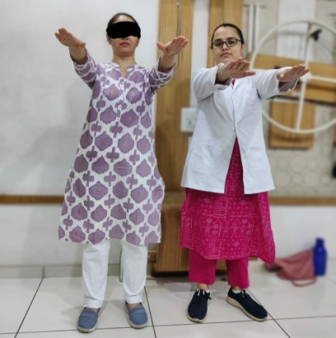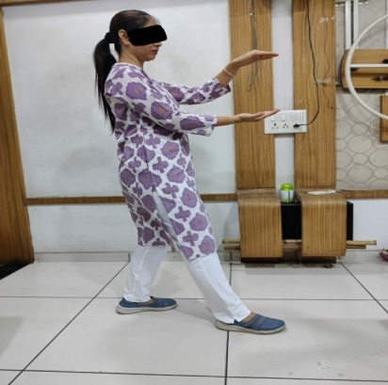

**Hip forward stretch Hip side stretch**

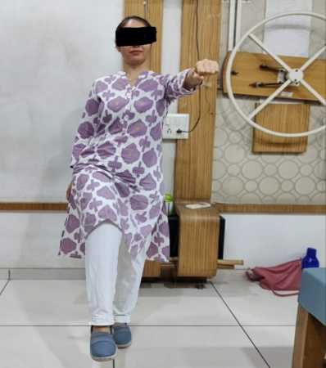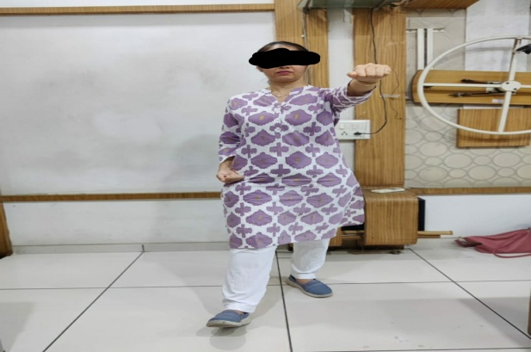

**Knees kick Step forward**

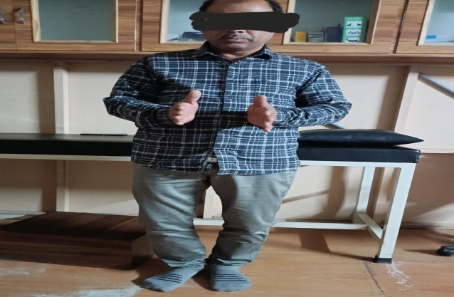 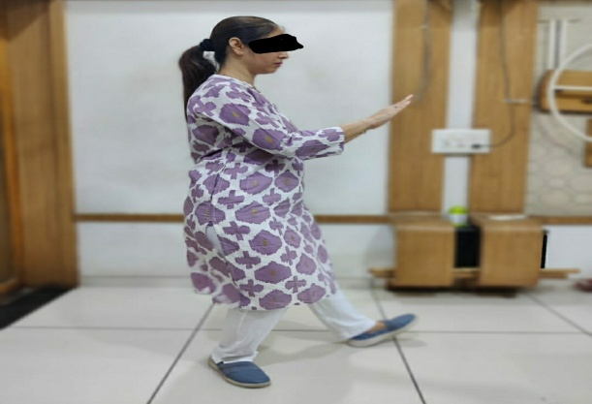

**Open and close posture Bow stance**

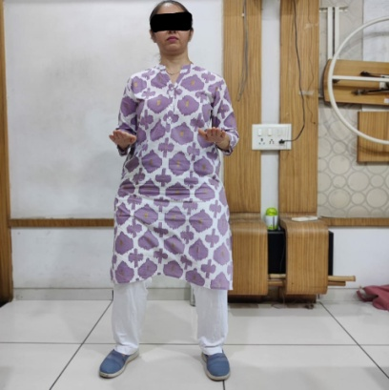 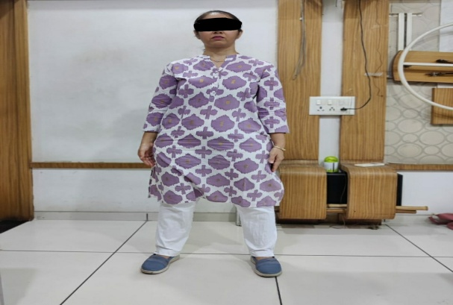

**Brush knees Stepping backwards**

**GROUP B: KINESIO TAPING WITH CONVENTIONAL EXERCISES:**

**1. KINESIO TAPING:109**

**Position:** Supine or sitting on the edge of chair with leg extended and thigh muscles relaxed.

**Taping method:**

**1. Medial tilt and medial glide:** Start the tape in the middle of the patella, at the level of the superior aspect of the patella, lift the skin on the medial side of the knee towards the patella and pull the tape medially. Fix the tape to the medial aspect of the knee just short of the hamstring tendons ensuring there is some slight wrinkling of the skin. This tilts the lateral patellar border away from the femur.

**2. Anteroposterior tilt and medial glide:** Start the rigid tape on the lateral aspect of the knee at the level of the superior aspect of the patella. Gently lift the skin on the medial side of the knee towards the patella as you pull the tape medially. Fix the tape to the medial aspect of the knee just short of the hamstring tendons ensuring there is some slight wrinkling of the skin.

**3. Unloading the infrapatellar fat pad and reducing stretch of inflamed soft tissues:** Commence the tape at the tibial tubercle and lift the soft tissue towards the patella, while firmly pulling the tape to the medial joint line. Repeat with a second piece of tape but firmly pull the tape toward the lateral joint line.

**Plate 2: Kinesio Taping**

**2. CONVENTIONAL PHYSIOTHERAPY:**Conventional Physiotherapy includes:

**1.** **Isometrics Quadriceps muscle exercise:** Position: Supine with knee extended. Method: Place a towel below knee. Move foot upwards and press knee down by tighten the muscle. Hold for 10 seconds and then relax.

**2. Isometrics Hamstring muscle exercise:** Position: Supine with knee slightly bent. Method: Place a towel below heel and press heel down. Hold for 10 seconds and then relax.

1. **Straight leg raising exercise:** Position: Supine with both knees extended.Method: Stabilize the leg straight by contracting quadriceps muscle and lift the leg straight. Hold for three to five seconds and slowly lower the leg to the floor with control.
2. **Vastus medialis obliqus strengthening exercise:** Position: Sitting on a chair**.** Method: place a ball between thighs and Squeeze the ball together. Hold for 10 seconds and then relax.
3. **High sitting Quadriceps drills exercise:** Position: Sitting with back supported and knee extended.Method: Place a towel below knee and press the towel by pushing knee down. Hold for 10 seconds and then relax.
4. **Hamstring stretching exercise:** Position: Supine with both leg extended.Method: Therapist holds one leg and lifts it upwards with both knees extended. Hold for 15 seconds and then slowly lower the leg to the floor.
5. **Therapeutic Ultrasound:**

Frequency: 1 MHz

Mode: Pulsed mode

M : S ratio: 1 : 1

Time: 5 Minutes.

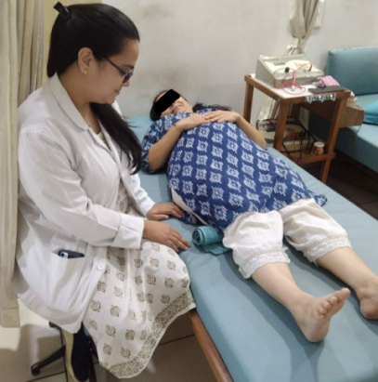 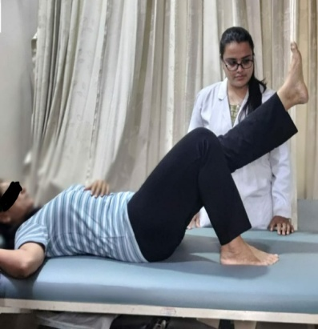

**Isometric Quadriceps exercise Straight leg rising**

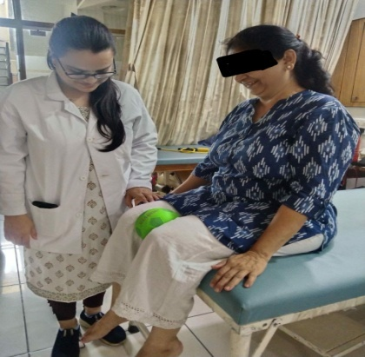 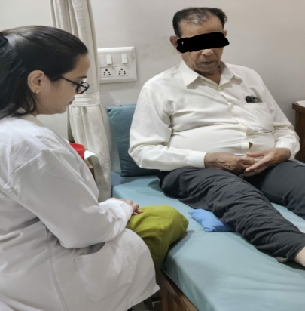

**Vastus Medialis Obliqus strengthening** **High sitting Quadriceps drills**

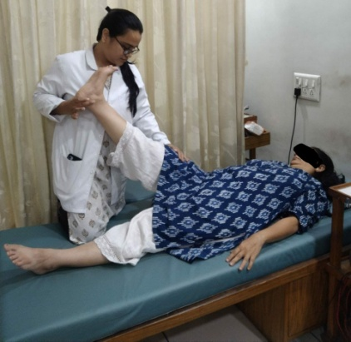 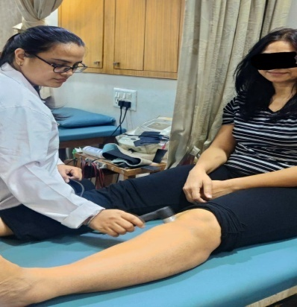

**Hamstring stretching exercise Therapeutic ultrasound**

Home exercises were prescribed to both the groups, which include: Quadriceps stretching exercise, Calf stretching exercise, Isometric Quadriceps exercise, Ankle toe movements.

Do’s and Dont’s was explained to both the groups, which include: Use western toilet, Avoid cross leg sitting, Avoid squatting, Avoid walk on uneven surfaces, Avoid standing for long duration.

RESULT: It was resulted that Group A treated with tai-chi exercises and group B treated with kinesio taping with conventional physiotherapy had almost equal effect on pain and tai-chi exercises had superior effects on reducing knee stiffness and improving physical functions in acute osteoarthritis of knee.

**DISCUSSION:** Knee osteoarthritis is a leading issue now a day and requires remarkable healthcare resources and involves considerable social costs for treatment, due to its progressive nature. Using Numerical Pain Rating Scale (NPRS) and Western Ontario and McMaster Universities Osteoarthritis Index (WOMAC), the purpose of this study was to assess the effects of tai-chi exercises and kinesiotaping with conventional physiotherapy in acute osteoarthritis of knee joint. Physical exercise can play a crucial role in the treatment of osteoarthritis in optimizing both physical and mental health, enhancing energy, decreasing fatigue and improving sleep. Biomechanical stimulus generated by dynamic compression during moderate exercise can reduce the synthesis of proteolytic enzymes, regulating the metabolic balance and preventing the progression of the disease.

Tai Chi is a kind of traditional art that is unique, internal and external training of body which supports both body and mind. It contains gentle joint ﬂexion, extension and circular movement of the limbs and the movement against resistance and gravity force. It also consists of concentration and respiration techniques mostly in the semi-squat state, which requires joint mobility, stability and balance.The sample consisted of 50 older adults diagnosed with acute osteoarthritis of knee, aged between 40 years to 50 years, randomly assigned as per inclusion and exclusion criteria to either in group A ie. experimental (n = 25) or group B ie. control (n = 25) group. Both groups attended 16 weekly, 40 minutes sessions at least 3 times each week. Participants in the group A received Tai Chi exercises and Group B received kinesio taping with conventional physiotherapy.

At pre and post-test, measures were collected for pain, stiffness and functional limitations. Pain intensity was measured by Numerical Pain Rating Scale (NPRS) and stiffness and functional limitation was assessed by Western Ontario and McMaster Universities Osteoarthritis Index (WOMAC). Present study showed the mean age of subjects in group A was 45.32±0.62 and in the group B was 46.04±0.64. The mean age of male patients in group A and B was 45.58±0.94 years and 45.75±0.98 years, respectively. The mean age of female patients in group A and B was 45.08±0.85 years and 46.31±0.85 years, respectively.

**WITHIN THE GROUP:** The present study looking at the effect of 16 weeks intervention of Tai Chi and kinesio taping with conventional physiotherapy on acute osteoarthritis of knee joint resulted in significant reduction of knee pain and improvement of arthritic symptoms. To find the significance of treatment within group analysis paired t test was used with p<0.05 considered as level of significance. The study showed that pain scores of Numerical Pain Rating Scale (NPRS) had significant reduction in pain intensity with pre and post value 7.52 and 2.32, respectively in group A. The p value was 0.0002, which showed extremely significant effect of tai chi exercises on pain status in acute osteoarthritis of knee. These findings were consistent with previous studies of Tai Chi by Song et al. (2003)116, Wang et al. (2009)117 and Lauche R (2013), they documented that Tai Chi exercises reduced pain and improved physical function, self-eﬃcacy, depression and health-related quality of life in patients with knee osteoarthritis. Tai Chi exercise could possibly have an essential eﬀect on removing pain materials and metabolites from the area and improves nutrition of the joint due to an increase in circulation; therefore, leads to pain reduction.

Group B treated with kinesio taping with conventional physiotherapy also showed significant reduction in pain intensity with pre and post value 7.56 and 2.64, respectively. The p value was 0.0002, which showed extremely significant effect of kinesio taping with conventional physiotherapy on pain status in acute osteoarthritis of knee. The studies by Baker et al. (2001),Cho et al. (2015) and Jebakani et al. (2015) corroborate the findings. Jan et al. (1991) found significant improvement after treatment with ultrasound therapy. Anand kumar et al. (2014) reported that therapeutic kinesio taping is effective in improving isokinetic quadriceps torque and reducing pain in knee osteoarthritis. Tripathi and Hande (2017) found that kinesio taping plus conventional exercise group studied in geriatric population showed signiﬁcant improvement of pain. The possible mechanism for pain relief by kinesio taping may be the stabilizing effect (structural support) of kinesio taping is believed to relief pain. In addition, the lifting effect of kinesio taping creates additional space between the dermis and the muscle. This additional space is supposed to relieve pressure on the pain receptors located under the skin resulting in pain relief.The present study resulted that both the techniques were almost equally effective on pain reduction in acute osteoarthritis of knee.

The total score of Western Ontario and McMaster Universities Osteoarthritis Index (WOMAC) in present study had significant improvement in pain, stiffness and physical functions with pre and post value 67.44 and 18.76, respectively in group A. The p value was 0.0001, which showed extremely significant effect of tai chi exercises on pain, stiffness and physical functions in acute osteoarthritis of knee. These findings were similar to previous studies on Tai Chi by Lee et al. (2008), Kang et al. (2011) and Ye et al. (2014),they reported thatTai Chi showed significant improvement in pain, physical function and stiffness. The possible reason for improvement pain, physical function and stiffness by Tai Chi exercises is that Tai Chi movements may increase joint lubrication and reduce swelling. The advantage of Tai Chi is a meditation in movement and can help the patient concentrate on movement and increase the patient motivation.

Group B also showed extremely significant improvement in pain, stiffness and physical functions with Western Ontario and McMaster Universities Osteoarthritis Index (WOMAC) pre and post value 67.44 and 18.76, respectively. The p value was 0.0001, which showed extremely significant effect of kinesio taping with conventional physiotherapy on pain, stiffness and physical functions in acute osteoarthritis of knee. These findings were consistent with previous studies of Kaya Mutlu et al. (2017)and Lu et al. (2018) reported that kinesio taping had beneﬁcial effects on pain relief, reducing joint stiffness, improve active range of motion and increasing knee function within short time. Regarding therapeutic ultrasound, Loyol-Senchez et al. (2010) and Tascioglu et al. (2010) found improvement in Western Ontario and McMaster Universities Osteoarthritis Index (WOMAC) as reduction of pain and physical function improved.Castrogiovanni et al. (2016) stated that effects of knee exercise and kinesio tape combined improve the physical limitations in patients with knee osteoarthritis.

**BETWEEN GROUPS:** In the present study no significant difference was found on comparing two groups for Numerical Pain Rating Scale (NPRS) score on knee joint pain in people suffering from acute osteoarthritis of knee. Numerical Pain Rating Scale (NPRS) pre and post-test scores were 7.52 and 2.32 for group A and 7.56 and 2.64 for group B, respectively. Both the groups showed improvement but one type of intervention could not be considered better than other one. Mean difference between both groups in post test scores was 0.32, which found slight variation on pain improvement in Tai Chi exercise group than kinesio taping with conventional physiotherapy group. The results of the study showed that both the techniques were almost equally effective on pain reduction in acute osteoarthritis of knee.

On other hand, there was significant difference was found when comparing both the groups for Western Ontario and McMaster Universities Osteoarthritis Index (WOMAC) total score of knee joint physical function, pain and stiffness in acute osteoarthritis of knee. Western Ontario and McMaster Universities Osteoarthritis Index (WOMAC) pre-test scores were 67.44 and 68.80 for group A and B, which was non-significant and post-test scores were 18.76 and 25.08 for group A and B, respectively. Post-test scores showed significant difference between groups. Mean post test difference between both groups was 6.32, which resulted that group A treated with Tai Chi exercises showed significant improvement on knee joint stiffness, pain and physical function than group B treated with kinesio taping with conventional physiotherapy in acute osteoarthritis of knee.

Several studies attribute these improvements from Tai Chi to components such as dynamic strengthening, improved joint stability, decreased joint pain, improved muscle flexibility, synergy between mental and physical health, and quality of life improvement. The study by Bannuru et al. (2012) and wang et al. (2016) was reported that tai chi exercises showed improvement in pain, physical functions and stiffness. Many study supported that knee kinesio taping and conventional physiotherapy effectively relieves knee pain and improves active range of motion. Sedhom (2016) and Ogut H et al. (2018) concluded that kinesio taping improves pain, muscle strength and knee joint functions. Reid DA et al. (2010), Page CJ (2011) and Fransen M et al. (2015) stated that knee muscle exercises improved knee joint functions.The result of the study showed that tai-chi exercises and kinesio taping with conventional physiotherapy had almost equal effect on pain and tai-chi exercises had superior effects on reducing knee stiffness and improving physical functions in acute osteoarthritis of knee. Hence, the present study stated that Tai Chi exercises and kinesio taping with conventional physiotherapy have got beneficial effect on alleviating the symptoms in acute osteoarthritis of knee patient.

**REFERENCES:**

1. White PH and Waterman M (22012). Making osteoarthritis a public health priority: several initiatives are placing this chronic illness on national agenda. Orthop Nurs.; 31: 92–97.
2. Glyn-Jones S, Palmer AJR, Agricola R, Price AJ, Vincent TL, Weinans H and Carr AJ (2015). Osteoarthritis. Lancet; 386: 376–387.
3. van Dijk GM, Dekker J, Veenhof C and van den Ende CHM (2006).Carpa Study Group Course of functional status and pain in osteoarthritis of the hip or knee: A systematic review of the literature. Arthritis Rheum; 55: 779–785.
4. Michael JW, Schluter-Brust KU andEysel P (2010). The epidemiology, etiology, diagnosis, and treatment of osteoarthritis of the knee. DtschArztebl Int.;107(9):152–62.
5. McCarthy CJ and OldhamJA (2013).The eﬀectiveness of exercise in the treatment of osteoarthritic knees: a critical review. PhysTher Rev.;4(4):241– 50.
6. Lim B (2002). A comparative study of open and closed kinetic chain exerciseregimesinpatientswithkneeosteoarthritis.PhysiotherSingapore;5:34–40.
7. Altman RD (1987). Criteria for classification of osteoarthritis of knee and hip. Scandinavian Journal of Rheumatology; (65): 31 – 39.
8. Felson DT and RC Lawrence (2000). Osteoarthritis: new insights. Part 1: the disease and its risk factors. Annals of Internal Medicine; 133(8): 635 – 4.
9. Chandra Prakash Pal, Pulkesh Singh1, Sanjay Chaturvedi, Kaushal Kumar Pruthi and Ashok Vij (2016). Epidemiology of knee osteoarthritis in India and related factors. Indian Journal of Orthopaedics; 50:518 – 22.
10. Heidari B (2011). Knee osteoarthritis prevalence, risk factors, pathogenesis and features: part I . Caspian J Intern Med.; 2:205 – 12.
11. Varady NH and Grodzinsky AJ (2016). Osteoarthritis year in review 2015: Mechanics. Osteoarthritis Cartilage; 24(1): 27 – 35.
12. Hsu H and Siwiec RM (2022). Knee Osteoarthritis. StatPearls Publishing, Treasure Island (FL)
13. Lepasio MJ Piuzzi NS, Husni ME, Muschler GF, Guarino AJ and Mont MA (2017). Knee osteoarthritis: A primer. The Permanente Journal; 21: 25 – 32.
14. Peat G, McCarney R and Croft P (2001). Knee pain and osteoarthritis in older adults: a review of community burden and current use of primary health care. Ann Rheum Dis; 60: 91–97.
15. Coggon D, Croft P, Kellingray S, Barrett D, McLaren M and Cooper C (2000). Occupational physical activities and osteoarthritis of the knee. Arthritis Rheum; 43: 1443 – 9.
16. Hillary J Braun and Garry E Gold (2012). Diagnosis of Osteoarthritis: Imaging. Bone; 51(2): 278 – 288.
17. Burks K (2005). Osteoarthritis in older adults: current treatments. J Gerontol Nurs; 31: 11 – 19.
18. Pinals RS (1992). Pharmacological treatment of osteoarthritis. Clin Ther; 14: 336 – 346.
19. Jamtvedt G, Dahm KT, Christie A, Moe RH, Haavardsholm E and Holm I (2008). Physical therapy interventions for patients with osteoarthritis of the knee: an overview of systematic reviews. Phys Ther.; 88: 123 – 36.
20. Axford J, Heron C, Ross F and Victor CR (2008). Management of knee osteoarthritis in primary care: pain and depression are the major obstacles. J Psychosom Res.; 64: 461 – 467.
21. Chen KM and Snyder M (1999). A research-based use of Tai Chi/movement therapy as a nursing intervention. J Holist Nurs; 17: 267 – 279.
22. Li JX, Hong Y and Chan KM (2001). Tai chi: physiological characteristics and beneficial effects on health. Br J Sports Med; 35: 148 – 156.
23. Lumsden DB, Baccala A and Martire J (1998). T’ai chi for osteoarthritis: an introduction for primary care physicians. Geriatrics; 53: 84 – 88.
24. Lee MS, Pittler MH and Ernst E (2008). Tai chi for osteoarthritis: a systematic review. ClinRheumatol; 27: 211 – 218.