**“STUDY TO EVALUATE ROLE OF CUPPING THERAPY VERSUS MYOFACIAL RELEASE FOR MANAGEMENT OF CHRONIC KNEE PAIN IN BADMINTON PLAYERS”**

### Purva Singh Khichi ,Dr. Kartik Sukhwal (M.P.T) (Musculoskeletal & sports)

INTRODUCTION

Patellar tendinopathy is a common and significant syndrome encountered in sports medicine referring to a clinical condition characterized by activity-related, anterior knee pain associated with focal patellar-tendon tenderness [1 –3]. Patellar tendinopathy is believed to result from repeated loading of the knee extensor mechanism and is thus most prevalent in sports involving some form of jumping [4]. In recognition of this association with jumping, patellar tendinopathy was first described and is commonly referred to as ‘‘jumper’s knee’’ [4– 8]. This term is misleading, however, as the condition is found in a wide variety of sports people, including those who do not participate in sports involving jumping [4,9 –11].Another traditionally popular term to describe the clinical condition is ‘‘patellar tendinitis.’’Histopathological studies, however, have consistently shown the pathology underlying patellar tendinopathy to be degenerative rather than inflammatory [10,12 – 14]; thus, the suffix -itis, implying the presence of inflammation, is inaccurate. To describe the histopathological presentation of the condition the term ‘‘tendinosis’’ is preferred [2,3,10] to clarify the terminology surrounding the syndrome, it has been advocated that the term patellar tendinopathy to be used clinically to describe overuse conditions of the patellar tendon [1– 3].Although extrinsic factors may be the most consistent causative factor in the development of tendinopathy, the development of patellar tendinopathy in some athletes while others with equivalent loading are spared signals that intrinsic factors must also contribute. Johnson et al [15] hypothesized that impingement of the inferior pole of the patella on to the tendon may contribute to the pathogenesis.This is supported by the findings of altered patella anteroposterior tilt [16] and a long inferior pole [15,16] in many knees with tendinopathy. To clarify the terminology surrounding the syndrome, it has been advocated that the term patellar tendinopathy to be used clinically to describe overuse conditions of the patellar tendon [1– 3].It is essential to know the prevalence and incidence rate of lower-extremity tendinopathies to shed light on the extent of their burden in general practice. This may also inform the planning of future research on tendinopathies by helping to establish the feasibility of recruiting from general practice for clinical studies and, moreover, depending on the distribution of the various tendinopathies, the need for prioritising between the different tendinopathies. The prevalence and incidence rate of lower-extremity tendinopathies in a dutch general practice population have previously been investigated, but never in a danish general practice setting. (15)Many factors, both intrinsic and extrinsic, contribute to patella tendinopathy. [16-17] Intrinsic factors such as strength imbalance,17 postural alignment,16,17 foot structure,16,17 reduced ankle dorsiflexion,18 and lack of muscle strength or flexibility17 may play a role. However the primary cause appears to relate to the extrinsic factor of overuse. For example, an increased physical load, repetition, intensity, frequency, and or duration of greater than 10% per week in the training schedule all contribute to this overuse syndrome.19 Additionally fatigue, poor technique, and training errors may play a role in this disorder.20,21 Further extrinsic etiologic considerations for injuries may include improper training surfaces, insufficient footwear or inappropriate equipment.20,22.Cupping therapy is a traditional complementary and alternative medicine technique used for thousands of years in countries such as China, Japan, Korea and Saudi Arabia.23 Cupping therapy has been proven effective in many kinds of diseases associated with pain, cardiovascular disorders, inflammatory and metabolic diseases,24 as well as musculoskeletal conditions such as low back and hip pain in soccer players,25 chronic neck pain26, pain related to carpal tunnel syndrome.27Myofascial decompression, as it is known in current Western medicine cultures, is a negative pressure soft tissue treatment technique utilized to manipulate the skin and fascial tissue. Using suction, the cups have the ability to grab and lift the fascia that may allow for lymphatic drainage of toxins, as well as stretching the fascial tissue.28.It is suggested that by using the appropriate cup size for the anatomical area being treated, there can be some relief of a deep fascial adhesion and allow for the muscle alone to move free of restriction.28 Using suction, the cups have the ability to grab and lift the fascia that may allow for lymphatic drainage of toxins, as well as stretching the fascial tissue.28Recently researchers have found that cupping therapy could alter skin blood flow29, change the biomechanical properties of the skin30, increase pressure pain thresholds in the neck31 and reduce inflammation.32 Despite low levels of clinical evidence, MFD is becoming a mainstream intervention for the treatment of musculoskeletal pain and dysfunction in sport. The mechanism of MFD is not completely understood, however some researchers suggest that placement of cups on selected acupoints on the skin produces hyperemia or hemostasis, which results in a therapeutic effect and that cupping therapy is of potential benefit for pain conditions.32Over the years, manual therapy techniques for the treatment of musculoskeletal conditions have become increasingly popular. Myofascial release (MFR) is one example of a manual therapy that has become widely used. Although its roots can be tracked to the 1940s, the term myofascial release was first coined in 1981 by Anthony Chila, DO; John Peckham, DO; and Carol Manheim, MEd, in a course titled “Myofascial Release” at Michigan State University. Despite the pervasiveness of MFR as a manual therapy, its effectiveness has not been objectively evaluated. Myofascial release has been commonly regarded as a therapeutic, post-exercise technique aimed towards repair and recovery (33-36). More recently, myofascial release has been regarded as a performance enhancing, pre-exercise technique within the athletic population (37, 38). Before the emergence of myofascial release as a pre-exercise technique, rehabilitation practitioners frequently explored the technique in alleviating pain and aiding in the recovery of physical activity. Pain and fatigue are often associated with particular trigger point tissue damage (36). One of the more commonly researched therapeutic approaches to pain and recovery has been trigger point soft tissue massage therapies (i.e., myofascial release techniques). Myofascial release research has shown to be effective in pain alleviation due to a series of physiological responses (33-34). The most common of these responses is an increase in the dilation of the arterial system (36)The vasodilation response is responsible for increased blood flow to the myofascial release sites. Other common responses associated with myofascial release include restoration of soft-tissue, increased nitrogen dioxide (NO2), and improved vascular plasticity (36). All of these responses have demonstrated a positive therapeutic effect on pain and recovery.

### METHODOLOGY

It is aComparative study design.60 players with chronic knee pain randomly selected according to the exclusion and inclusion criteria and will be divided into two groups.Group 1: Cupping therapy + conventional exercise Group 2: MFR + conventional exercises.8 weeks (30 minutes per day, 3 days in a week.)

### OUTCOME MEASURES

1. Visual analogue scale

Reliability of VAS for actue pain management as assessed by the ICC appears to be high. 90 patient of the pain rating were reproducible within 9mm. these data suggest that the VAS is sufficient reliable to be used to asses acute pain.

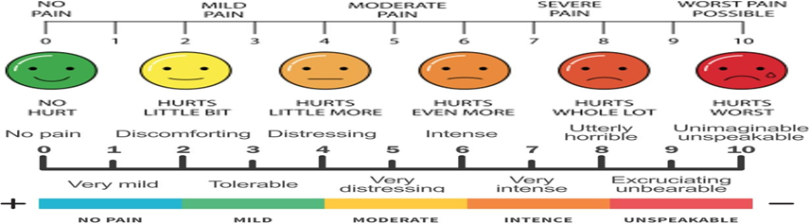

2. Knee injury and osteoarthritis outcome score ( KOOS)

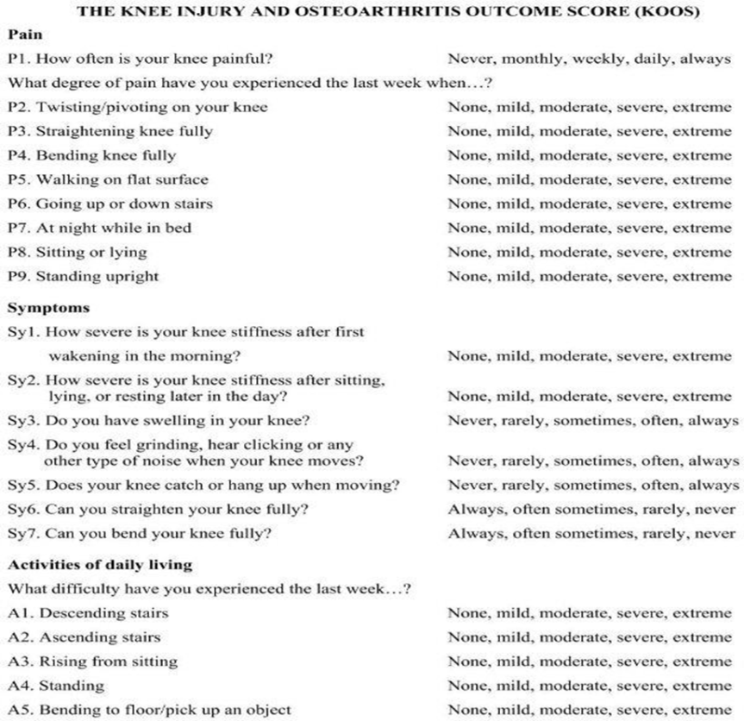

### INCLUSION CRITERIA:

* Male and female aged 15-30 years
* History of Patellar Tendinopathy
* Anterior knee pain located on inferior pole of the patella
* Tenderness of the superior insertion of the pateller tendon.

### EXCLUSION CRITERIA:

* Knee surgery
* Chronic joint deformity
* Major musculoskeletal impairments in the joint.
* Age below 15 and age above 30 year

### Procedure

After collecting the written consent form the patients selected by inclusion and exclusion criteria they would be divided into two group- group A and group B.Major muscle group like quadricep muscles would be targeted.The selection of the muscles will remine same in both the groups. The technique and duration of the treatment would differ for the groups.

**GROUP A**: CUPPING THERAPY + CONVIENTIAL EXERCISES.

Patient position: supine lying on the couch with the head rested on the pillow with the hand by the side.Therapist position: therapist standing near the affected side of the leg near the couch. Each treatment session while be of 15 – 20 min. for muscles.

* + Checking for contraindication:
    - Temperature
    - Skin condition
    - Open wound
  + Procedure:
    - Treatment area should be clean and shave.
    - Application of the lubricant.
    - Dynamic cupping targeting the quadricep muscles. (procedure for 1-2 mins.)
    - Application of the cups, generating suction on vastus intermedius, vastus lateralis, vastus medialis, rectus femoris. (10 mins.)
    - Continuous checking of vaccum.
    - Removal of the cups and cleaning of the patient.
    - Lymphatic drainage of the area where cupping was applied.
    - Icing if needed

Stretching: Patient position to side lying, knee flexed to 20 degree, therapist position to back side of the patient holding the ankle, flexed to a bearable stretch according to the patient with the hold of 10 secs and release back.

* + Exercises:
    - SLR ( patient position – supine lying )
    - Side SLR (patient position – side lying )
    - Q drill (patient position – long sitting )
    - Isometric exercise.

Repetition of each exercise is 10 reps. And with the 10 secs hold.

**GROUP B:** MYOFASCIAL RELEASE + CONVIENTAL EXERCISE.

Myofascial release therapy can also improve skeletal and muscular alignment prior to a surgery, or help athletes achieve better alignment prior to sports competitions.

By targeting specific areas of the fascial system, myofascial therapy provide pain relief for patients with restricted flexibility and movement, thus allowing patients to return to normal movement and greater function.

The treatment session is followed by the isometric and isokinetic exercises of knee joint.

* Patient position : Supine lying of the couch with head rested on the pillow and both the arm rested on the abdomen with affected side hanging of the edge of the treatment couch .
* Therapists position: Long sitting near the treatment couch on the affected side of the body.
  + Procedure :
    - Knee movement conducted to rectify the stiffness of the muscles.
    - Application of the lubricant to avoid irritation of the skin.
    - Holding the muscle individually followed by the knee flexion to check the stiffness of induvial muscles.
    - Hold periphery of the muscles with thenar eminence and other hand glide throughout the second periphery with a former pressure.
    - Repetitive movement for the next 3-4 min for each muscles.

#### Exercises :

* + - SLR ( patient position – supine lying )
    - Side SLR (patient position – side lying )
    - Q drill (patient position – long sitting )
    - Isometric exercise.

Repetition of each exercise is 10 reps. And with the 10 secs hold.

### DATA ANALYSIS

This study aimed to compare the analysis of Cupping therapy and MFR for management of chronic knee pain in badminton players. The researchers used statistical tools such as paired and unpaired t-tests to analyze the data. Collected data on two different days: Days 0 and 60th day.

By comparing the pre-test and post-test values, they found differences in the mean values of the VAS and KOOS between the two groups. The researcher analyzed and interpreted the significance of these differences using the t-values obtained from the tests. The statistical tools used for analysis were paired and unpaired “t” test.

Arithmetic Mean:

Where,

The mean of the value was calculated using the formula given below:

__ ∑x

X ═ ──

N

X ═ Arithmetic Mean

∑x ═ Sum of all variables

N ═ Total number of variables

Standard Deviation (SD):

The standard deviation was calculated using the formula given below:

__

√(X -X) 2 SD ═ —————

√N

Where,

X ═ Mean of scores

X ═ Sum of all variables

N ═ Total number of variables

__

(X -X) 2═ Deviation

PAIRED ‘t’ TEST WITHIN GROUP:

The paired ‘t’ test was used to find out the significance within the same group with the values of parameters considered for the study.

The formula to find the value of paired ‘t’ test:

[M1-M2]

t ═ ————— SEMd

Where,

M1 ═ Mean 1 M2 ═ Mean 2

SEMd ═ Standard Error of Mean difference

SEMd ═ √SEM12 + SEM22 – 2r SEM1 SEM2

r ═ correlation between Group A and Group B df ═ N – 1

UNPAIRED ‘t’ TEST BETWEEN GROUP:

The ‘t’ test was used to find out the significance between the groups and it gives the valuable information regarding this study.

The formula to find the value of ‘t’ using unpaired ‘t’ test for Group A v/s Group B: [M1-M2]

t ═ ————— SEMd

Where,

M1 ═ Mean 1 M2 ═ Mean 2

SEMd ═ Standard Error of Mean difference

SEMd ═ √SEM12 + SEM22

σ1 SEM1 ═ ——

√N1

σ2

SEM2 ═ ————

√N2

df ═ N1 + N2 – 2

Where,

σ ═ Standard Deviation SEM ═ Standard Error of Mean

SEMd ═ Standard Error of Mean difference M ═ Mean

### RESULT

The purpose of this research was to compare the analysis of Cupping therapy and MFR for management of chronic knee pain in badminton players. The collected data was organized into tables and subjected to statistical analysis to interpret the results. In this chapter, we will present and discuss the findings of the study, which are divided into the following main sections:

##### Distribution of the study group based on gender.

1. Presentation of demographic data in different groups.

##### Examining the significance of pre-test and post-test values of VAS within Group A.

1. Assessing the significance of pre-test and post-test values of VAS within Group B.

##### Analyzing the significance of pre-test and post-test values of KOOS within Group A.

1. Evaluating the significance of pre-test and post-test values of KOOS within Group B.

##### Comparing VAS scores between Group A and Group B.

1. Comparing KOOS scores between Group A and Group B.

##### GENDER-WISE DISTRIBUTION OF THE STUDY GROUP

TABLE: 1

|  |  |  |
| --- | --- | --- |
| Group | MALE | FEMALE |
| GROUP A | 14 | 16 |
| GROUP B | 21 | 9 |
| TOTAL | 35 | 25 |

Group A has 14 males and 16 females. And Group B has 21 males and 9 females.

The total count of males in the study group is 14 + 21 = 35, and the total count of females is 16 + 9 = 25.

Percentage of males in the total count =

(Total males / Total count) * 100 = (35 / 60) * 100 ≈ 58.33% Percentage of females in the total count =

(Total females / Total count) * 100 = (25 / 60) * 100 ≈ 41.67%

GRAPH 1

##### 40

**35**

##### 30

**25**

##### 20

**15**

##### 10

**5**

##### 0

##### MALE FEMALE

The male-to-female ratio in the total study group is approximately 1.4, indicating that there are more males than females in the group. About 58.33% of the total study group consists of males, while approximately 41.67% are females.

##### DEMOGRAPHIC PRESENTATION OF DATA IN GROUPS:

Appears to be a demographic breakdown of two groups (Group A and Group B) based on their age in years. Group A: Number of individuals: 30 Mean age: 23.13 years Standard Error of the Mean (SEM): 0.17 years Standard Deviation (SD): 5.23 years. Group B: Number of individuals: 30 Mean age: 21.7 years Standard Error of the Mean (SEM): 0.13 years Standard Deviation (SD): 3.92 years. Total (Combined Groups A and B): Number of individuals: 60 (30 from Group A + 30 from Group B) Mean age: 44.83 years Standard Error of the Mean (SEM):

0.30 years Standard Deviation (SD): 9.15 years

##### TABLE 2

|  |  |  |  |
| --- | --- | --- | --- |
| GROUPS | NUMBER | AGE IN YEARS | |
| MEAN±SEM | SD |
| Group A | 30 | 23.13±0.17 | 5.23 |
| Group B | 30 | 21.7±0.13 | 3.92 |
| Total | 60 | 44.83±0.30 | 9.15 |

**GRAPH 2**

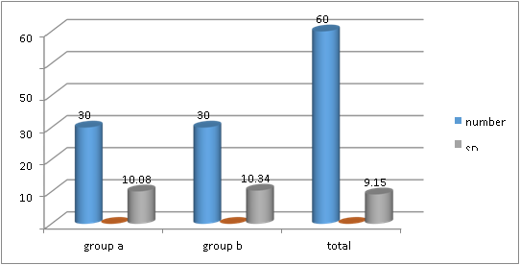

**INTERPRETATION:** The study's participant groups exhibit different age distributions, with Group A having a slightly higher mean age than Group B. The combined data underscore an overall mean age of approximately 45 years, accompanied by considerable variability in age across the entire sample.

##### Examining the significance of pre-test and post-test values of VAS within Group A.

**TABLE 3**

|  |  |  |  |  |  |  |  |
| --- | --- | --- | --- | --- | --- | --- | --- |
|  | Mean | N | SD | Std. error  mean | Mean  diff. | T | P |
| Pre test | 7.96 | 30 | 1.35 | 0.24 | 3.96 | 9.33 | <0.003 |
| Post test | 4.0 | 30 | 2.08 | 0.38 |

*significant

##### GRAPH 3

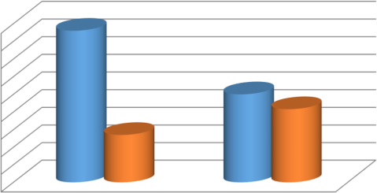

4.5

4

3.5

3

2.5

2

1.5

1

0.5

0

Mean

SD

Pre test Post test

**INTERPRETATION :** In this section of the analysis, the significance of pre-test and post-test values of the Visual Analog Scale (VAS) within Group A. The pre-test results for Group A revealed a mean VAS score of 7.96, accompanied by a standard deviation (SD) of 1.35 and a standard error of the mean (SEM) of 0.24. After the intervention, Group A's post-test mean VAS score was found to be 4.0, with a relatively higher SD of 2.08 and a SEM of 0.38. post-test score represents the group's condition or perception following the intervention. The pivotal finding in this analysis is the mean difference between the pre-test and post-test VAS scores within Group A, which stands at 3.96. This significant mean difference is corroborated by a high t-value of 9.33 and a corresponding p-value significant.

##### Assessing the significance of pre-test and post-test values of VAS within Group B.

**TABLE 4**

|  |  |  |  |  |  |  |  |
| --- | --- | --- | --- | --- | --- | --- | --- |
|  | Mean | N | SD | Std. error  mean | Mean  diff. | T | P |
| Pre test | 7.6 | 30 | 1.40 | 0.25 | 4.74 | 12.97 | <0.004* |
| Post test | 2.86 | 30 | 1.56 | 0.28 |

*significant

**GRAPH 4**

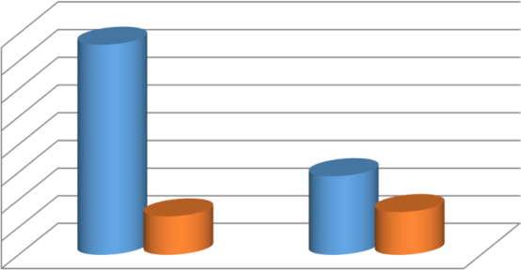

8

7

6

5

4

3

2

1

0

Mean

SD

Pre test Post test

**INTERPRETATION:**The pre-test and post-test values of VAS within Group B exhibit a notable and statistically significant difference. Prior to any intervention, the mean pre-test VAS score was 7.6 (SD = 1.40), whereas after the intervention, the mean post-test score decreased substantially to 2.86 (SD = 1.56). The mean difference of 4.74 between the pre-test and post-test scores was statistically significant, as evidenced by a t-statistic of 12.97 (p < 0.004*). This indicates that the intervention implemented in Group B had a significant and positive impact, leading to a significant reduction in VAS scores, which suggests an improvement in the assessed variable.

##### Analyzing the significance of pre-test and post-test values of KOOS within Group A.

**TABLE 5**

|  |  |  |  |  |  |  |  |
| --- | --- | --- | --- | --- | --- | --- | --- |
|  | Mean | N | SD | Std. error  mean | Mean  diff. | T | P |
| Pre test | 46.13 | 30 | 7.85 | 1.43 | 22.9 | 11.39 | <0.001* |
| Post test | 69.03 | 30 | 9.32 | 1.70 |

**\***significant

**GRAPH 5**

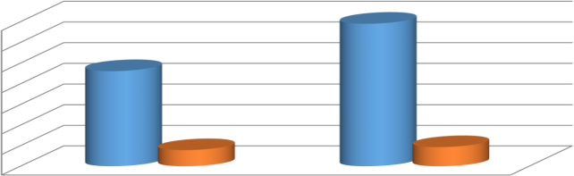

70

60

50

40

30

Mean

SD

20

10

0

Pre test

Post test

**INTERPRETATION:**The pre-test and post-test values of the Knee injury and Osteoarthritis Outcome Score (KOOS) within Group A reveal a significant and notable difference. Prior to any intervention or treatment, the mean KOOS score for Group A participants was 46.13, with a standard deviation of 7.85. After undergoing the prescribed intervention, the post-test KOOS score rose dramatically to 69.03, accompanied by a standard deviation of 9.32. This substantial increase in mean KOOS scores, representing an impressive mean difference of 22.9, indicates a substantial improvement in the participants' knee- related outcomes. The paired t-test conducted to assess this difference yielded a highly significant p- value of less than 0.001, underscoring the statistical significance of this improvement. In concise terms, the results suggest that the intervention administered to Group A has had a substantial and statistically significant positive impact on their knee health and function, as evidenced by the remarkable increase in their KOOS scores

##### Evaluating the significance of pre-test and post-test values of KOOS within Group B.

**TABLE 6**

|  |  |  |  |  |  |  |  |
| --- | --- | --- | --- | --- | --- | --- | --- |
|  | Mean | N | SD | Std. error  mean | Mean  diff. | T | P |
| Pre test | 47.8 | 30 | 3.86 | 0.70 | 32.2 | 22.06 | * |
| Post test | 80.0 | 30 | 7.76 | 1.41 |

**\***significant

**GRAPH 6**

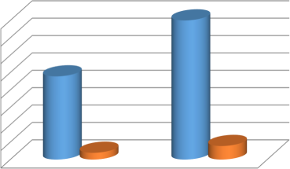

80

70

60

50

40

30

20

10

0

Mean

SD

Pre test Post test

**INTERPRETATION:**The pre-test and post-test values of the Knee Injury and Osteoarthritis Outcome Score (KOOS) within Group B demonstrate a significant difference. Before any intervention or treatment, the mean pre- test KOOS score for Group B participants was 47.8, with a standard deviation of 3.86 and a standard error of the mean of 0.70. After the intervention or treatment, the mean post-test KOOS score increased substantially to 80.0, accompanied by a higher standard deviation of 7.76 and a standard error of the mean of 1.41.The significant mean difference of 32.2 (p < 0.001) between the pre-test and post-test values indicates a substantial improvement in knee function and overall quality of life for individuals within Group B following the intervention. The asterisk (*) denotes statistical significance, signifying that the observed change is not likely due to chance alone but is instead a result of the intervention applied. the data reveals a noteworthy improvement in KOOS scores within Group B, suggesting that the intervention or treatment had a positive and statistically significant impact on the participants' knee health and well-being.

##### Comparing VAS scores between Group A and Group B.

|  |  |  |  |  |  |  |  |
| --- | --- | --- | --- | --- | --- | --- | --- |
|  | Mean | N | SD | Std. error  mean | Mean  diff. | T | P |
| GROUP A | 4.0 | 30 | 2.08 | 0.38 | 1.14 | 2.37 | 0.02* |
| GROUP B | 2.86 | 30 | 1.56 | 0.28 |

**\*significant**

**GRAPH 7**

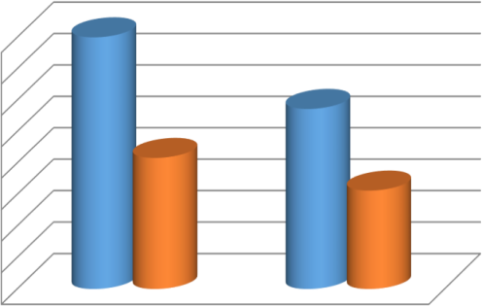

4

3.5

3

2.5

2

1.5

1

0.5

0

Mean

SD

GROUP A GROUP B

**INTERPRETATION:**The comparison of Visual Analog Scale (VAS) scores between Group A and Group B reveals a statistically significant difference. In Group A, the mean VAS score was 4.0, with a standard deviation of 2.08 and a standard error of the mean of 0.38. Group B had a slightly lower mean VAS score of 2.86, with a standard deviation of 1.56 and a standard error of the mean of 0.28.The significant mean difference of 1.14 (p = 0.02) indicates that Group A participants reported higher pain levels, on average, compared to Group B. The asterisk (*) denotes statistical significance, suggesting that this difference is unlikely to be due to chance and is instead associated with the groups themselves, possibly reflecting the effectiveness of different treatments or interventions.the VAS score comparison highlights that Group A experienced significantly higher levels of pain compared to Group B. This finding suggests that there may be variations in pain management or outcomes between these two groups, emphasizing the potential impact of different interventions or treatments on pain perception.

##### Comparing KOOS scores between Group A and Group B.

|  |  |  |  |  |  |  |  |
| --- | --- | --- | --- | --- | --- | --- | --- |
|  | Mean | N | SD | Std. error  mean | Mean  diff. | T | P |
| GROUP A | 69.03 | 30 | 9.32 | 1.70 | 10.97 | 4.95 | 0.002 |
| GROUP B | 80.0 | 30 | 7.76 | 1.41 |

**GRAPH 8**

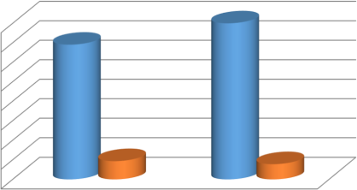

80

70

60

50

40

30

20

10

0

Mean

SD

Pre test Post test

INTERPRETATION:The comparison of Knee Injury and Osteoarthritis Outcome Score (KOOS) scores between Group A and Group B demonstrates a statistically significant difference. In Group A, the mean KOOS score was 69.03, with a standard deviation of 9.32 and a standard error of the mean of 1.70. Group B, on the other hand, had a higher mean KOOS score of 80.0, accompanied by a standard deviation of 7.76 and a standard error of the mean of 1.41. The substantial mean difference of 10.97 (p = 0.002) indicates that Group B participants had significantly higher KOOS scores, on average, compared to those in Group A. This statistical significance suggests that the observed difference in KOOS scores is unlikely to be attributed to random chance and may be attributed to the interventions or treatments administered to each group the KOOS score comparison reveals that participants in Group B experienced significantly better knee-related outcomes compared to Group A. This finding underscores the potential effectiveness of the interventions or treatments applied in Group B in improving knee health and functionality.

**Discussion**

Cupping is an ancient method of treatment that has been used in the treatment and cure of a broad range of conditions; blood diseases such as haemophilia and hypertension, rheumatic conditions ranging from arthritis, sciatica, back pain, migraine, anxiety and general physical and mental well-being. The aim of Cupping is to extract blood that is believed to be harmful from the body which in turn rids the body of potential harm from symptoms leading to a reduction in well-being.

Traditionally, Cupping Therapy has been practiced in most cultures in one form or another. In the UK the practice of Cupping Therapy also dates back a long way with one of the leading medical journals ‘The Lancet' being named after this practice. A lancet is a piece of surgical equipment that was traditionally utilised to release excess blood i.e. venesection and to prick boils. The Arabic name for Cupping Therapy is Al-Hejamah which means to reduce in size i.e. to return the body back to its natural state. The practice of Al-Hejamah has been part of Middle Eastern cultural practice for thousands of years with citations dating back to the time of Hippocrates (400 BC). Of the western world, the first to embrace Cupping Therapy were the ancient Egyptians, and the oldest recorded medical textbook, Ebers Papyrus, written in approximately 1550 BC in Egypt mentions cupping (Curtis, 2005). Cupping Therapy can be divided into two broad categories: Dry Cupping and Wet Cupping. Dry Cupping Therapy tends to be practiced more commonly in the Far-East whereas Wet Cupping is favoured in the Middle East and Eastern Europe. For the purpose of this research Wet Cupping Therapy will be investigated and the referred to as Cupping Therapy.

Outcome measures that were used were the Pain Visual Analogue Scale (Pain VAS), Well Being Visual Analogue Scale (Well Being VAS) and joint range of motion, both Active Range of Motion (AROM) and Passive Range of Motion (PROM). The independent variable in this study was the treatment of Cupping Therapy, which all participants received. The independent variables measured were Pain and Well-being VAS scales and Active and Passive Knee Ranges of Movement.

The term myofascial pain is defined as “the complex of sensory, motor, and autonomic symptoms caused by MTrPs” (Simons et al., 1999). MTrPs, hyperirritable spots found in the skeletal muscles, are associated with hypersensitive palpable nodules located in a taut band. The spots are painful on compression and may produce characteristic referred pain, referred tenderness, motor dysfunction, and autonomic phenomena.

Myofascial release (MFR) is one of the frequently applied mechanical approaches that generally enhance soft tissue extensibility with the help of compression or reestablishing the limited fascia/ordinary muscle length by mechanical forces of low load and lengthy duration. Among the distinct methods that operate on the structures of fascial tissue, the method of myofascial Release technique (MRF) was regarded to have pain lessening potentiality, improvement of flexibility, reduction of disability, and hence the improvement of function in daily living activities .

### Conclusion

The study concludes both Cupping therapy and MFR had significant effects on chronic knee pain but while comparing it showed that group treated with the MFR has statistically more significant effect than the group treated with cupping therapy for chronic knee pain.

**LIMITATIONS OF THE STUDY**

1. The study was limited due to shorter duration of treatment.
2. The study was limited due to less number of chronic knee pain patients.
3. The study was limited age group between 10-30 years.
4. The study was limited to lower limb involvement in chronic knee pain patients.

### RECOMMENDATIONS FOR FURTHER STUDY

1. It may be recommended that treatment course could be of prolong duration, so that more results could be evaluated.
2. Further study could be design with large number of sample size.
3. It may be recommended that study could be done on different age groups.
4. It may be recommended that more studies are needed to be done in various techniques to improve in chronic knee pain patients.

### REFRENCES

1. Khan KM, Cook JL, Kannus P, et al. Time to abandon the ‘‘tendinitis’’ myth. BMJ 2002;324: 626 – 7.
2. Khan KM, Cook JL, Taunton JE, et al. Overuse tendinosis, not tendinitis. Part 1: a new paradigm for a difficult clinical problem. Phys Sportsmed 2000;28:38 – 48.
3. Maffulli N, Khan KM, Puddu G. Overuse tendon conditions: time to change a confusing terminology. Arthroscopy 1998;14:840 – 3.
4. Cook JL, Khan KM, Harcourt PR, et al. A cross sectional study of 100 athletes with jumper’s knee managed conservatively and surgically. Br J Sports Med 1997;31:332 – 6. +6+32+
5. Blazina ME, Kerlan RK, Jobe FW, et al. Jumper’s knee. Orthop Clin North Am 1973;4: 665 – 78.
6. Ferretti A. Epidemiology of jumper’s knee. Sports Med 1986;3:289 – 95.
7. Ferretti A, Conteduca F, Camerucci E, et al. Patellar tendinosis: a follow-up study of surgical treatment. J Bone Joint Surg 2002;84A:2179 – 85.
8. Fritschy D, de Gautard R. Jumper’s knee and ultrasonography. Am J Sports Med 1988;16:637 – 40.
9. Cannell LJ, Taunton JE, Clement DB, et al. A randomised clinical trial of the efficacy of drop squats or leg extension/leg curl exercises to treat clinically diagnosed jumper’s knee in athletes: pilot study. Br J Sports Med 2001;35:60 – 4.
10. Khan KM, Bonar F, Desmond PM, et al. Patellar tendinosis (jumper’s knee): findings at histopathologic examination US, and MR imaging. Radiology 1996;200:821 – 7.
11. Taunton JE, Ryan MB, Clement DB, et al. A retrospective case-control analysis of 2002 running injuries. Br J Sports Med 2002;36:95 – 101.
12. Fu SC, Wang W, Pau HM, et al. Increased expression of transforming growth factor- beta1 in patellar tendinosis. Clin Orthop 2002;400:174 – 83.
13. Khan KM, Cook JL, Bonar F, et al. Histopathology of common tendinopathies: update and implications for clinical management. Sports Med 1999;27:393 – 408.
14. Yu JS, Popp JE, Kaeding CC, et al. Correlation of MR imaging and pathologic findings in athletes undergoing surgery for chronic patellar tendinitis. Am J Roentgenol 1995;165:115 – 8.
15. Albers IS, Zwerver J, Diercks RL, Dekker JH. Van den Akker-Scheek I. incidence and prevalence of lower extremity tendinopathy in a Dutch general practice population: a cross sectional study. BMC Musculoskelet Disord. 2016;17(1):16
16. Cook JLKhan KMMaffulli Net al. Overuse tendinosis, not tendinitis. part 2: applying the new approach to patellar tendinopathy. *The Phys and*

*Sportsmedicine.* 2000;28(6):1–11 [[PubMed](https://pubmed.ncbi.nlm.nih.gov/20086644)] [[Google Scholar](https://scholar.google.com/scholar_lookup?journal=The%2BPhys%2Band%2BSportsmedicine.&title=Overuse%2Btendinosis%2C%2Bnot%2Btendinitis.%2Bpart%2B2%3A%2Bapplying%2Bthe%2Bnew%2Bapproach%2Bto%2Bpatellar%2Btendinopathy&author=JL%2BCook&author=KM%2BKhan&author=N%2BMaffulli&volume=28&issue=6&publication_year=2000&pages=1-11)]

1. 12. Witvrouw EBellemans JLysenset al. Intrinsic risk factors for the development of patellar tendinitis in an athletic population: a two-year prospective study. *Am J Sports Med.* 2001;29(2):190–95 [[PubMed](https://pubmed.ncbi.nlm.nih.gov/11292044)] [[Google Scholar](https://scholar.google.com/scholar_lookup?journal=Am%2BJ%2BSports%2BMed.&title=Intrinsic%2Brisk%2Bfactors%2Bfor%2Bthe%2Bdevelopment%2Bof%2Bpatellar%2Btendinitis%2Bin%2Ban%2Bathletic%2Bpopulation%3A%2Ba%2Btwo-year%2Bprospective%2Bstudy&author=E%2BWitvrouw&author=J%2BBellemans&author=%2BLysens&volume=29&issue=2&publication_year=2001&pages=190-95&pmid=11292044)]
2. . Malliaras PCook JLKent P. Reduced ankle dorsiflexion range may increase the risk of patellar tendon injury among volleyball players. *J Sci Med Sport.* 2006;9(4):304–9 [[PubMed](https://pubmed.ncbi.nlm.nih.gov/16672192)] [[Google Scholar](https://scholar.google.com/scholar_lookup?journal=J%2BSci%2BMed%2BSport.&title=Reduced%2Bankle%2Bdorsiflexion%2Brange%2Bmay%2Bincrease%2Bthe%2Brisk%2Bof%2Bpatellar%2Btendon%2Binjury%2Bamong%2Bvolleyball%2Bplayers&author=P%2BMalliaras&author=JL%2BCook&author=P%2BKent&volume=9&issue=4&publication_year=2006&pages=304-9&pmid=16672192)]
3. Matava MD. *American Orthopedic Society for Sports Medicine*.

2008. [http://www.sportsmed.org/secure/reveal/admin/uploads/documents/ST%20Ove](http://www.sportsmed.org/secure/reveal/admin/uploads/documents/ST%20Overuse%20Injuries%2008.pdf) [ruse%20Injuries%2008.pdf](http://www.sportsmed.org/secure/reveal/admin/uploads/documents/ST%20Overuse%20Injuries%2008.pdf) Accessed 4/4/10. [[Google Scholar](https://scholar.google.com/scholar_lookup?title=American%2BOrthopedic%2BSociety%2Bfor%2BSports%2BMedicine&author=MD%2BMatava&publication_year=2008)]

1. Magra MMaffulli N. Genetic aspects of tendinopathy. *J Sci and Med Sport.* 2008;11(3):243–47 [[PubMed](https://pubmed.ncbi.nlm.nih.gov/17870670)] [[Google Scholar](https://scholar.google.com/scholar_lookup?journal=J%2BSci%2Band%2BMed%2BSport.&title=Genetic%2Baspects%2Bof%2Btendinopathy&author=M%2BMagra&author=N%2BMaffulli&volume=11&issue=3&publication_year=2008&pages=243-47&pmid=17870670)]
2. Almekinders LCTemple JD. Etiology, diagnosis, and treatment of tendonitis: an analysis of the literature. *Med Sci Sports Exerc.* 1998;30(8):1183–90

[[PubMed](https://pubmed.ncbi.nlm.nih.gov/9710855)] [[Google Scholar](https://scholar.google.com/scholar_lookup?journal=Med%2BSci%2BSports%2BExerc.&title=Etiology%2C%2Bdiagnosis%2C%2Band%2Btreatment%2Bof%2Btendonitis%3A%2Ban%2Banalysis%2Bof%2Bthe%2Bliterature&author=LC%2BAlmekinders&author=JD%2BTemple&volume=30&issue=8&publication_year=1998&pages=1183-90&pmid=9710855)]

1. Kim KH, Kim TH, Hwangbo M, Yang GY. Anaemia and skin pigmentation after Chen B Li MY Liu PD, et al. Alternative medicine: an update on cupping therapy. *Q J Med.* 2015;108:523–525. [[PubMed](https://pubmed.ncbi.nlm.nih.gov/25399022)] [[Google Scholar](https://scholar.google.com/scholar_lookup?journal=Q%2BJ%2BMed.&title=Alternative%2Bmedicine%3A%2Ban%2Bupdate%2Bon%2Bcupping%2Btherapy&author=B%2BChen&author=MY%2BLi&author=PD%2BLiu&volume=108&publication_year=2015&pages=523-525)]
2. Qureshi NA Ali GI Abushanab TS, et al. History of cupping (Hijama): a narrative review of literature. *J Integr Med.* 2017;15(3):172–181. [[PubMed](https://pubmed.ncbi.nlm.nih.gov/28494847)] [[Google Scholar](https://scholar.google.com/scholar_lookup?journal=J%2BIntegr%2BMed.&title=History%2Bof%2Bcupping%2B(Hijama)%3A%2Ba%2Bnarrative%2Breview%2Bof%2Bliterature&author=NA%2BQureshi&author=GI%2BAli&author=TS%2BAbushanab&volume=15&issue=3&publication_year=2017&pages=172-181&pmid=28494847)]
3. Bridgett R Klose P Duffield R, et al. Effects of cupping therapy in amateur and professional athletes: systematic review of randomized controlled trials. *J Altern Complement Med.* 2018;24(3):208-219. [[PubMed](https://pubmed.ncbi.nlm.nih.gov/29185802)] [[Google Scholar](https://scholar.google.com/scholar_lookup?journal=J%2BAltern%2BComplement%2BMed.&title=Effects%2Bof%2Bcupping%2Btherapy%2Bin%2Bamateur%2Band%2Bprofessional%2Bathletes%3A%2Bsystematic%2Breview%2Bof%2Brandomized%2Bcontrolled%2Btrials&author=R%2BBridgett&author=P%2BKlose&author=R%2BDuffield&volume=24&issue=3&publication_year=2018&pages=208-219&pmid=29185802)]
4. Lauche R Cramer H Choi K-E, et al. The influence of a series of five dry cupping treatments on pain and mechanical thresholds in patients with chronic non-specific neck pain—a randomised controlled pilot study. *BMC Complement Altern Med.* 2011;11:63. [[PMC free article](https://www.ncbi.nlm.nih.gov/pmc/articles/PMC3224248/)] [[PubMed](https://pubmed.ncbi.nlm.nih.gov/21843336)] [[Google Scholar](https://scholar.google.com/scholar_lookup?journal=BMC%2BComplement%2BAltern%2BMed.&title=The%2Binfluence%2Bof%2Ba%2Bseries%2Bof%2Bfive%2Bdry%2Bcupping%2Btreatments%2Bon%2Bpain%2Band%2Bmechanical%2Bthresholds%2Bin%2Bpatients%2Bwith%2Bchronic%2Bnon-specific%2Bneck%2Bpain%E2%80%94a%2Brandomised%2Bcontrolled%2Bpilot%2Bstudy&author=R%2BLauche&author=H%2BCramer&author=K-E%2BChoi&volume=11&publication_year=2011&pages=63&pmid=21843336)]
5. Michalsen A Bock S Lüdtke R, et al. Effects of traditional cupping therapy in patients with carpal tunnel syndrome: a randomized controlled trial. *J Pain.* 2009;10(6):601- 608. [[PubMed](https://pubmed.ncbi.nlm.nih.gov/19380259)] [[Google Scholar](https://scholar.google.com/scholar_lookup?journal=J%2BPain.&title=Effects%2Bof%2Btraditional%2Bcupping%2Btherapy%2Bin%2Bpatients%2Bwith%2Bcarpal%2Btunnel%2Bsyndrome%3A%2Ba%2Brandomized%2Bcontrolled%2Btrial&author=A%2BMichalsen&author=S%2BBock&author=R%2BL%C3%BCdtke&volume=10&issue=6&publication_year=2009&pages=601-608&pmid=19380259)]
6. Tham LM Lee HP Lu C. Cupping: from a biomechanical perspective. *J Biomech.* 2006;39(12):2183-2193. [[PubMed](https://pubmed.ncbi.nlm.nih.gov/16126216)] [[Google Scholar](https://scholar.google.com/scholar_lookup?journal=J%2BBiomech.&title=Cupping%3A%2Bfrom%2Ba%2Bbiomechanical%2Bperspective&author=LM%2BTham&author=HP%2BLee&author=C%2BLu&volume=39&issue=12&publication_year=2006&pages=2183-2193&pmid=16126216)]
7. Liu W Piao S Meng X, et al. Effects of cupping on blood flow under skin of back in healthy human. *World J Acupuncture Moxibustion.* 2013;23:50–52. [[Google Scholar](https://scholar.google.com/scholar_lookup?journal=World%2BJ%2BAcupuncture%2BMoxibustion.&title=Effects%2Bof%2Bcupping%2Bon%2Bblood%2Bflow%2Bunder%2Bskin%2Bof%2Bback%2Bin%2Bhealthy%2Bhuman&author=W%2BLiu&author=S%2BPiao&author=X%2BMeng&volume=23&publication_year=2013&pages=50-52)]
8. Roostayi MM Norouzali T Manshadi FD, et al. The effects of cupping therapy on skin's biomechanical properties in wistar rats. *Chinese Medicine.* 2016;7:25-30. [[Google](https://scholar.google.com/scholar_lookup?journal=Chinese%2BMedicine.&title=The%2Beffects%2Bof%2Bcupping%2Btherapy%2Bon%2Bskin%27s%2Bbiomechanical%2Bproperties%2Bin%2Bwistar%2Brats&author=MM%2BRoostayi&author=T%2BNorouzali&author=FD%2BManshadi&volume=7&publication_year=2016&pages=25-30) [Scholar](https://scholar.google.com/scholar_lookup?journal=Chinese%2BMedicine.&title=The%2Beffects%2Bof%2Bcupping%2Btherapy%2Bon%2Bskin%27s%2Bbiomechanical%2Bproperties%2Bin%2Bwistar%2Brats&author=MM%2BRoostayi&author=T%2BNorouzali&author=FD%2BManshadi&volume=7&publication_year=2016&pages=25-30)]
9. Emerich M Braeunig M Clement HW, et al. Mode of action of cupping—local metabolism and pain thresholds in neck pain patients and healthy subjects. *Complement Ther Med*. 2014;22:148–58. [[PubMed](https://pubmed.ncbi.nlm.nih.gov/24559830)] [[Google Scholar](https://scholar.google.com/scholar_lookup?journal=Complement%2BTher%2BMed&title=Mode%2Bof%2Baction%2Bof%2Bcupping%E2%80%94local%2Bmetabolism%2Band%2Bpain%2Bthresholds%2Bin%2Bneck%2Bpain%2Bpatients%2Band%2Bhealthy%2Bsubjects&author=M%2BEmerich&author=M%2BBraeunig&author=HW%2BClement&volume=22&publication_year=2014&pages=148-58&pmid=24559830)]
10. Lin ML Lin CW Hsieh YH et al. Evaluating the effectiveness of low level laser and cupping on low back pain by checking the plasma cortisol level. Paper presented at: 2014 IEEE International Symposium on Bioelectronics and Bioinformatics (IEEE ISBB 2014); April 11-14, 2014; location; Chung Li, Taiwan. <http://ieeexplore.ieee.org/document/6820906/>. Accessed July 26, 2017.
11. Cao H Li X Liu J. An Updated Review of the Efficacy of Cupping Therapy. *PLoS ONE.* 2012; 7(2): e31793. 10.1371/journal.pone.0031793. [[PMC free](https://www.ncbi.nlm.nih.gov/pmc/articles/PMC3289625/) [article](https://www.ncbi.nlm.nih.gov/pmc/articles/PMC3289625/)] [[PubMed](https://pubmed.ncbi.nlm.nih.gov/22389674)] [[Google Scholar](https://scholar.google.com/scholar_lookup?journal=PLoS%2BONE.&title=An%2BUpdated%2BReview%2Bof%2Bthe%2BEfficacy%2Bof%2BCupping%2BTherapy&author=H%2BCao&author=X%2BLi&author=J%2BLiu&volume=7&issue=2&publication_year=2012&pages=e31793&pmid=22389674)]
12. Anderson R, Wise D, Sawyer T, Nathanson BH. Safety and effectiveness of an internal pelvic myofascial trigger point wand for urologic chronic pelvic pain syndrome. *Clin J Pain.* 2011;27(9):764–8. [[PubMed](https://pubmed.ncbi.nlm.nih.gov/21613956)] [[Google Scholar](https://scholar.google.com/scholar_lookup?journal=Clin%2BJ%2BPain&title=Safety%2Band%2Beffectiveness%2Bof%2Ban%2Binternal%2Bpelvic%2Bmyofascial%2Btrigger%2Bpoint%2Bwand%2Bfor%2Burologic%2Bchronic%2Bpelvic%2Bpain%2Bsyndrome&author=R%2BAnderson&author=D%2BWise&author=T%2BSawyer&author=BH%2BNathanson&volume=27&issue=9&publication_year=2011&pages=764-8&pmid=21613956)]
13. Anderson RU, Wise D, Sawyer T, Glowe P, Orenberg EK. 6-day intensive treatment protocol for refractory chronic prostatitis/chronic pelvic pain syndrome using myofascial release and paradoxical relaxation training. *J Urol.* 2011;185(4):1294–

9. [[PubMed](https://pubmed.ncbi.nlm.nih.gov/21334027)] [Google Scholar]

1. Ma C, Wu S, Li G, Xiao X, Mai M, Yan T. Comparison of miniscalpel-needle release, acupuncture needling, and stretching exercise to trigger point in myofascial pain syndrome. *Clin J Pain.* 2010;26(3):251–7. [[PubMed](https://pubmed.ncbi.nlm.nih.gov/20173440)] [Google Scholar
2. Okamoto T, Masuhara M, Ikuta K. Acute Effects of Self-Myofascial Release Using a Foam Roller on Arterial Function. *J Strength Cond Res.* 2013 [[PubMed](https://pubmed.ncbi.nlm.nih.gov/23575360)] [[Google](https://scholar.google.com/scholar_lookup?journal=J%2BStrength%2BCond%2BRes&title=Acute%2BEffects%2Bof%2BSelf-Myofascial%2BRelease%2BUsing%2Ba%2BFoam%2BRoller%2Bon%2BArterial%2BFunction&author=T%2BOkamoto&author=M%2BMasuhara&author=K%2BIkuta&publication_year=2013) [Scholar](https://scholar.google.com/scholar_lookup?journal=J%2BStrength%2BCond%2BRes&title=Acute%2BEffects%2Bof%2BSelf-Myofascial%2BRelease%2BUsing%2Ba%2BFoam%2BRoller%2Bon%2BArterial%2BFunction&author=T%2BOkamoto&author=M%2BMasuhara&author=K%2BIkuta&publication_year=2013)]
3. MacDonald GZ, Penney MD, Mullaley ME, Cuconato AL, Drake CD, Behm DG, Button DC. An acute bout of self-myofascial release increases range of motion without a subsequent decrease in muscle activation or force. *J Strength Cond Res.* 2013;27(3):812–21. [[PubMed](https://pubmed.ncbi.nlm.nih.gov/22580977)] [[Google Scholar](https://scholar.google.com/scholar_lookup?journal=J%2BStrength%2BCond%2BRes&title=An%2Bacute%2Bbout%2Bof%2Bself-myofascial%2Brelease%2Bincreases%2Brange%2Bof%2Bmotion%2Bwithout%2Ba%2Bsubsequent%2Bdecrease%2Bin%2Bmuscle%2Bactivation%2Bor%2Bforce&author=GZ%2BMacDonald&author=MD%2BPenney&author=ME%2BMullaley&author=AL%2BCuconato&author=CD%2BDrake&volume=27&issue=3&publication_year=2013&pages=812-21&pmid=22580977)]
4. Renan-Ordine R, Alburquerque-Sendín F, de Souza DP, Cleland JA, Fernández-de- Las-Peñas C. Effectiveness of myofascial trigger point manual therapy combined with a self-stretching protocol for the management of plantar heel pain: a randomized controlled trial. *J Orthop Sports Phys Ther.* 2011;41(2):43–50. [[PubMed](https://pubmed.ncbi.nlm.nih.gov/21285525)] [[Google](https://scholar.google.com/scholar_lookup?journal=J%2BOrthop%2BSports%2BPhys%2BTher&title=Effectiveness%2Bof%2Bmyofascial%2Btrigger%2Bpoint%2Bmanual%2Btherapy%2Bcombined%2Bwith%2Ba%2Bself-stretching%2Bprotocol%2Bfor%2Bthe%2Bmanagement%2Bof%2Bplantar%2Bheel%2Bpain%3A%2Ba%2Brandomized%2Bcontrolled%2Btrial&author=R%2BRenan-Ordine&author=F%2BAlburquerque-Send%C3%ADn&author=DP%2Bde%2BSouza&author=JA%2BCleland&author=C%2BFern%C3%A1ndez-de-Las-Pe%C3%B1as&volume=41&issue=2&publication_year=2011&pages=43-50&pmid=21285525) [Scholar](https://scholar.google.com/scholar_lookup?journal=J%2BOrthop%2BSports%2BPhys%2BTher&title=Effectiveness%2Bof%2Bmyofascial%2Btrigger%2Bpoint%2Bmanual%2Btherapy%2Bcombined%2Bwith%2Ba%2Bself-stretching%2Bprotocol%2Bfor%2Bthe%2Bmanagement%2Bof%2Bplantar%2Bheel%2Bpain%3A%2Ba%2Brandomized%2Bcontrolled%2Btrial&author=R%2BRenan-Ordine&author=F%2BAlburquerque-Send%C3%ADn&author=DP%2Bde%2BSouza&author=JA%2BCleland&author=C%2BFern%C3%A1ndez-de-Las-Pe%C3%B1as&volume=41&issue=2&publication_year=2011&pages=43-50&pmid=21285525)]
5. Cook JL, Khan KM. What is the appropriate treatment for patellar tendinopathy? Br J Sports Med 2001;35(5):291–4.
6. Khan KM, Cook JL, Bonar F, et al. Histopathology of common overuse tendon conditions: update and implications for clinical management. Sports Med 1999;27:393–408.
7. Hamilton B, Purdam C. Patellar tendinosis as an adaptive process: a new hypothesis. Br J Sports Med 2004;38:758–61.
8. Cook J, Feller JA, Bonar SF, et al. Abnormal tenocyte morphology is more prevalent than collagen disruption in asymptomatic athletes patellar tendons. J Orthop Res 2004;22:334–8.
9. Khan KM, Cook JL, Maffulli N, et al. Where is the pain coming from in tendinopathy? It may be biochemical, not only structural, in origin. Br J Sports Med 2000;34:81–3.
10. Cook JL, Khan KM, Harcourt PR, et al. Patellar tendon ultrasonography in asymptomatic active athletes reveals hypoechoic regions: a study of 320 tendons. Victorian Institute of Sport Tendon Study Group. Clin J Sport Med. 1998;8:73–77.
11. Coombes BK, Bisset L, Vicenzino B. A new integrative model of lateral epicondylalgia. Br J Sports Med. 2009;43:252–258.
12. Rio E, Moseley L, Purdam C, et al. The pain of tendinopathy: physiological or pathophysiological? Sports Med. 2014;44:9–23.
13. Eccleston C, Crombez G. Pain demands attention: a cognitive-affective model of the interruptive function of pain. Psychol Bull. 1999;125:356–366.
14. Berryman C, Stanton TR, Jane Bowering K, et al. Evidence for working memory deficits in chronic pain: a systematic review and meta-analysis. Pain. 2013;154:1181– 1196.
15. Khan KM, Cook JL, Kannus P, Maffulli N, Bonar SF: Time to abandon the “tendinitis” myth. BMJ 2002;324(7338)
16. Lian OB, Engebretsen L, Bahr R: Prevalence of jumper’s knee among elite athletes from different sports: A cross-sectional study. Am J Sports Med 2005;33(4):561-567.
17. Hägglund M, Zwerver J, Ekstrand J: Epidemiology of patellar tendinopathy in elite male soccer players. Am J Sports Med 2011;39(9):1906-1911.
18. Zwerver J, Bredeweg SW, van den Akker-Scheek I: Prevalence of Jumper’s knee among nonelite athletes from different sports: A cross-sectional survey. Am J Sports Med 2011;39(9): 1984-1988.

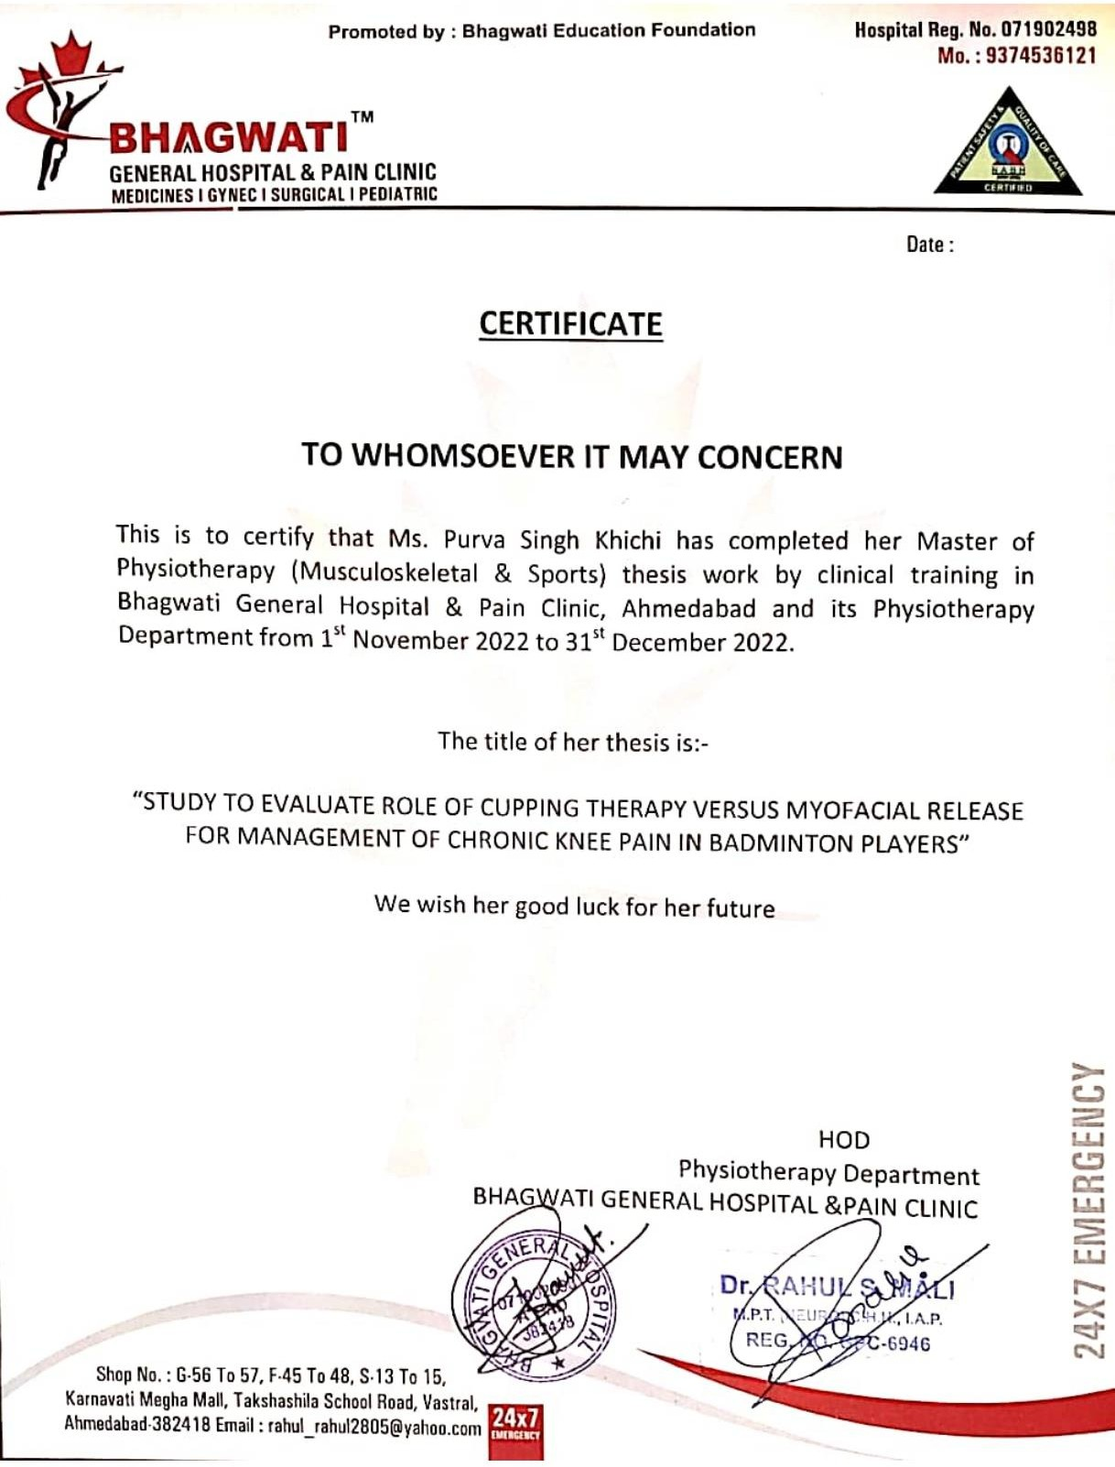

## ANNEXURES

### CONSENT FORM

TITLE: “STUDY TO EVALUATE ROLE OF CUPPING THERAPY VERSUS MYOFACIAL RELEASE FOR MANAGEMENT OF CHRONIC KNEE PAIN IN BADMINTON PLAYERS”

Investigator: PURVA SINGH

##### Purpose of the Study:

I have been informed that this study will help to understand the role

of cupping therapy versus myofascial release for management of chronic knee pain in badminton players”. This questionnaire and tests will help the health professionals.

##### Procedure:

I have been explained that, this study will be conducted by questionnaire and manual test methods. I understand that all questions in this questionnaire consist about knee pain Patients and test will be done to check my present condition. I also understand that the questions have to be answered on the basis of my present pain condition. I am aware that, I have to follow the instructions accordingly.

##### Risk and Discomfort:

I understand that there is no potential risk associated with testing procedure and this study will not produce any harm to me by answering the questions in the questionnaire. I understand that there won’t be any discomfort throughout the study. I am aware that PURVA SINGH will be with me during the procedure.

##### Request for more information:

I understand that if I ask any question about this study at any time, PURVA SINGH will be available to answer my questions. Copy of this consent form will be given to me for careful reading.

##### Refusal or withdrawal of participation:

I understand that my participation is voluntary and I may refuse to withdraw consent and discontinue participation at any time. I also understand that she may terminate my participation at any time after explaining the reasons for doing so.

##### Injury statement:

I understand that in the unlikely event of injury resulting directly or indirectly to me during participation in this study, medical treatment would be available but no further compensation will be provided. I understand my agreement to participate in this study and I am not waiving any of my legal rights.

I have explained , the purpose of the

research, the procedure, possible risks and benefits to the best of my knowledge.

Date: Investigator

I confirm that PURVA SINGH has explained the purpose

of the research, the procedure, possible risks and benefits that I may experience. I have read and understand this consent to participate as a subject in this synopsis work.

Date: Participant’s signature

Witness Signature

### GENERAL ASSESMENT

NAME : OP/IP NO. :

AGE : DATE OF ASSESSMENT:

SEX : OCCUPATION:

ADDRESS:

CHIEF COMPLAINTS

HISTORY OF PRESENT ILLNESS PAST MEDICAL/SURGICAL HISTORY SOCIAL HISTORY

ECONOMIC STATUS

**PAIN ASSESMENT**

SITE/SIDE :

DURATION :

ON SET :

TYPE :

NATURE :

RADIATING PAIN : AGGREVATING FACTOR : RELEAVING FACTOR : CONSTANT/INTERMITTENT : VAS :

**ON OBSERVATION**

Built of patient :

Swelling :

Color change :

Scar :

Open Wound/Ulcer :

Contracture :

Muscle wasting :

Posture :

Gait :

Deformity :

External appliances :

**ON PALPATION**

Tenderness :

Warmthness :

Crepitis :

Effusion :

**ON EXAMINATION**

ROM :

|  |  |  |
| --- | --- | --- |
| NAME OF JOINT | ACTIVE ROM | PASSIVE ROM |
|  |  |  |

MMT :

|  |  |  |
| --- | --- | --- |
| NAME OF MUSCLE | RIGHT SIDE | LEFT SIDE |

LIMB LENGTH : LIMB GIRTH :

SENSORY EXAMINATION: SPECIAL TEST :

**INVESTIGATIONS**

**DIAGNOSIS**

PROVISIONAL DIAGNOSIS DIFFERENTIAL DIAGNOSIS

**TREATMENT** PROBLEMS LIST : AIM :

MEAN :

DO’s :

DON’Ts :

##### Master chart of group A

|  |  |  |  |  |  |  |
| --- | --- | --- | --- | --- | --- | --- |
| **S.NO.** | **SEX** | **AGE** | **VAS** | | **KOOS** | |
| **PRE-TEST** | **POST-TEST** | **PRE-TEST** | **POST-TEST** |
| 1 | F | 22 | 7 | 2 | 70 | 100 |
| 2 | F | 21 | 7 | 3 | 75 | 100 |
| 3 | F | 15 | 8 | 2 | 80 | 90 |
| 4 | M | 24 | 9 | 3 | 90 | 100 |
| 5 | F | 25 | 8 | 2 | 85 | 95 |
| 6 | F | 26 | 8 | 2 | 88 | 95 |
| 7 | M | 18 | 8 | 4 | 80 | 90 |
| 8 | F | 21 | 8 | 4 | 80 | 90 |
| 9 | M | 22 | 8 | 5 | 80 | 90 |
| 10 | M | 23 | 9 | 4 | 90 | 100 |
| 11 | M | 17 | 9 | 2 | 90 | 100 |
| 12 | F | 22 | 9 | 3 | 90 | 100 |
| 13 | M | 28 | 9 | 2 | 90 | 100 |
| 14 | F | 14 | 7 | 4 | 70 | 90 |
| 15 | F | 25 | 9 | 5 | 90 | 100 |
| 16 | M | 20 | 9 | 6 | 90 | 100 |
| 17 | M | 27 | 8 | 2 | 85 | 95 |
| 18 | F | 18 | 8 | 4 | 85 | 95 |
| 19 | M | 27 | 8 | 2 | 85 | 95 |
| 20 | M | 24 | 8 | 3 | 85 | 95 |
| 21 | F | 22 | 7 | 2 | 70 | 100 |
| 22 | F | 21 | 7 | 3 | 75 | 100 |
| 23 | F | 20 | 8 | 2 | 80 | 90 |
| 24 | M | 24 | 9 | 3 | 90 | 100 |
| 25 | F | 18 | 8 | 2 | 85 | 95 |
| 26 | F | 26 | 8 | 2 | 88 | 95 |
| 27 | M | 22 | 8 | 4 | 80 | 90 |
| 28 | F | 21 | 8 | 4 | 80 | 90 |
| 29 | M | 28 | 8 | 5 | 80 | 90 |
| 30 | M | 23 | 9 | 4 | 90 | 100 |

**Master chart of group B:**

|  |  |  |  |  |  |  |
| --- | --- | --- | --- | --- | --- | --- |
| **S.NO.** | **SEX** | **AGE** | **VAS** | | **KOOS** | |
| **PRE-TEST** | **POST-TEST** | **PRE-TEST** | **POST-TEST** |
| 1 | F | 25 | 9 | 5 | 90 | 100 |
| 2 | M | 26 | 9 | 6 | 90 | 100 |
| 3 | M | 27 | 8 | 2 | 85 | 95 |
| 4 | F | 28 | 8 | 4 | 85 | 95 |
| 5 | M | 27 | 8 | 2 | 85 | 95 |
| 6 | M | 27 | 8 | 3 | 85 | 95 |
| 7 | F | 22 | 7 | 2 | 70 | 100 |
| 8 | F | 21 | 7 | 3 | 75 | 100 |
| 9 | F | 20 | 8 | 2 | 80 | 90 |
| 10 | M | 24 | 9 | 3 | 90 | 100 |
| 11 | F | 18 | 8 | 2 | 85 | 95 |
| 12 | F | 22 | 9 | 3 | 90 | 100 |
| 13 | M | 19 | 9 | 2 | 90 | 100 |
| 14 | F | 13 | 7 | 4 | 70 | 90 |
| 15 | F | 25 | 9 | 5 | 90 | 100 |
| 16 | F | 22 | 7 | 2 | 70 | 100 |
| 17 | F | 21 | 7 | 3 | 75 | 100 |
| 18 | F | 15 | 8 | 2 | 80 | 90 |
| 19 | M | 24 | 9 | 3 | 90 | 100 |
| 20 | F | 21 | 8 | 2 | 85 | 95 |
| 21 | F | 26 | 8 | 2 | 88 | 95 |
| 22 | M | 18 | 8 | 4 | 80 | 90 |
| 23 | F | 21 | 8 | 4 | 80 | 90 |
| 24 | M | 20 | 8 | 5 | 80 | 90 |
| 25 | M | 18 | 9 | 4 | 90 | 100 |
| 26 | M | 24 | 9 | 3 | 90 | 100 |
| 27 | F | 18 | 8 | 2 | 85 | 95 |
| 28 | F | 26 | 8 | 2 | 88 | 95 |
| 29 | M | 22 | 8 | 4 | 80 | 90 |
| 30 | F | 21 | 8 | 4 | 80 | 90 |